The commissioning progress of microwave imaging reflectometer on EAST tokamak

Lifu ZHANG,a Jinuo Yu,a Jinchen Yang,a Ge Zhuanga and Jinlin XIE a,1

1. Department of Plasma Physics and Fusion Engineering, USTC,  
   Hefei, China

*E-mail*: jlxie@ustc.edu.cn

Abstract: A 96-channel W-band (75–110 GHz) microwave imaging reflectometer (MIR) has been designed and developed for 2D electron density fluctuation measurements on the Experimental Advanced Superconducting Tokamak (EAST). The system features 12 poloidal channels with eight distinct radial viewing depths. An advanced front-end transmitter and receiving optics system has been implemented on-site, offering extensive flexibility for various plasma scenarios through dynamic adjustments of the transmitter beam wavefront shape, poloidal zoom, and full-frequency radial focus depth. The experiment’s signal-to-noise ratio has been enhanced by increasing the MIR illumination system’s output power. To minimize crosstalk, the eight-tone reflectometer frequencies are selected with gaps. The thresholds for signal-to-noise ratio and fluctuation reconstruction uncertainty have been quantitatively evaluated through precise bench-top experiments. Clear observations of 1D poloidal coherent modes have been achieved using the EAST MIR system.

Keywords: Density fluctuation; Microwave reflectometry; Space echo.

Contents

1. Introduction 1

2. Plasma Accessibility 3

3. MIR Hardware 3

3.1 Upgrade of RF system 3

3.2 MIR Electronics 4

3.3 Optical components 6

4. The chopper experiment 7

4.1 The quality of the MIR raw data 7

4.2 The diagram of the chopper experiment. 7

4.3 Results of the chopper experiment. 9

5. Preliminary experimental results of the MIR system on EAST. 10

6. Summary 12

1. Introduction

Active microwave reflectometer is widely employed for both electron density equilibrium profile and fluctuation measurements [1-2]. The cutoff layer is usually assumed to be an ideal flat surface for reflection, which ensures a neat interpretation of the diagnostic data. For instance, the density fluctuation level is proportional to the phase variation level. However, the assumption is questionable in real case considering the 2-D density fluctuations (both in the radial and in the poloidal direction) developed on cutoff layer with different spatial scales. Consequently, the perturbed cutoff layer would act like a diffraction grating and the reflected wave scatters over a large solid angle. Since the distance between the cutoff layer and the receiver is usually much larger than the “diffraction distance”, the possible resulted interference will make it difficult to interpret data. Thus a front-end Gaussian optical collective receiving system with large-aperture is proposed to help reconstruct the correct wavefront at the receiver position [3-4], which re-assure the clean and simple data interpretation. With the aid of large-aperture optical collective receiving system, it is nature to replace the single detector with 1-D detector vertical array and increase the number of transmitter frequencies, which realize the microwave imaging reflectometer (MIR) diagnostic system [Add reference about the MIR principle]. With the capability to visualize the 2D electron density fluctuations in the poloidal and radial cross-section on the Tokamaks and Stellarators, MIR systems had been developed in TEXTOR [5], DIII-D [6], WEST [7], KSTAR [8], LHD [9] and HL-2A [10]. Unlike the passive 2D imaging radiometer, Electron Cyclotron Emission Imaging (ECEI), MIR measurements encounter greater challenges in achieving clear 2D density fluctuation imaging. These challenges stem from complex coherent wave receiving, interference between different poloidal and radial channels, and potential misalignment between the transmitter wavefront and the plasma cutoff layer. Despite these difficulties, the MIR system offers a unique capability for co-located and simultaneous measurements of both density and temperature fluctuations alongside ECEI. This capability is essential and highly valuable for studying MHD instabilities and turbulence transport in long-pulse plasma discharges. A clear understanding of these physical phenomena is crucial for the design and safe operation of fusion plasma devices.

The EAST MIR system was developed and implemented following the laboratory characterization [12], sharing part of its front-end optics and vacuum port with the Electron Cyclotron Emission Imaging diagnostic, as illustrated in Fig. 1. The MIR transmitter beam (Tx) operates at eight distinct frequencies, enabling density fluctuation measurements at varying depths. The transmitter optics adjust the beam wavefront to closely match the curvature of the plasma cutoff layer, ensuring near-normal incidence across different poloidal heights for 2D measurements [Zhu, Y., et al., "The general optics structure of millimeter-wave imaging diagnostic on tokamak." *Journal of Instrumentation*, 11.01 (2016): P01004]. This wavefront matching maintains a nearly constant phase front at the fluctuating cutoff layer, optimizing the coupling of reflected beam power back to the receiver system and enhancing measurement signal quality. The receiving optics (Rx) then collect the reflected beams from the curved plasma cutoff layer. As depicted in Fig. 1, a W-band beam splitter separates the transmitted and received beams. The spatial structure of density fluctuations near the cutoff layer is reconstructed by analyzing the reflected wavefront at the image plane, preserving the accuracy of phase measurements. [13].

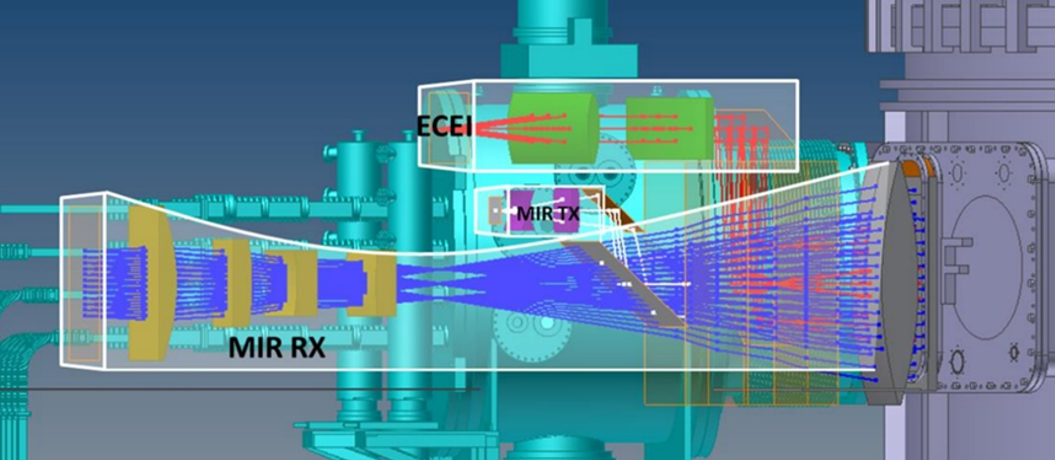

**Figure 1.** Schematic of a 2-D MIR diagnostic system on EAST.

This paper presents an overview of the hardware design and challenges encountered during the implementation of the EAST MIR system. Section II discusses the fundamental constraints on MIR, focusing on plasma accessibility. Section III covers the transmitter and receiver optical systems and electronics, including upgrades to the transmitter source, suppression of back-end electronics crosstalk, and improvements in optical performance. In Section IV, the artificial phase modulation testing platform is described, along with laboratory test results that quantitatively assess the thresholds for signal-to-noise ratio and fluctuation reconstruction uncertainty. Section V presents preliminary plasma measurement results from EAST. Finally, Section VI summarizes the status of the EAST MIR system and ongoing efforts to enhance signal quality.Preliminary experimental results of the MIR system on EAST.

1. Plasma Accessibility

Based on the standard EAST discharge configuration, the radial distribution of plasma characteristic frequencies with a toroidal magnetic field around 2.3T is shown in Fig. 2. The MIR transmitter beam, consisting of eight different frequencies, is launched from the low-field-side vacuum window. The transmitter frequencies are carefully selected to match the cutoff frequencies at the targeted radial depths while avoiding resonance layers along the propagation path. As shown in Fig. 2, the W-band (75-110 GHz) frequency range provides wide radial accessible range (normal radius from 0.35 to 0.9) with X-mode operation mode.

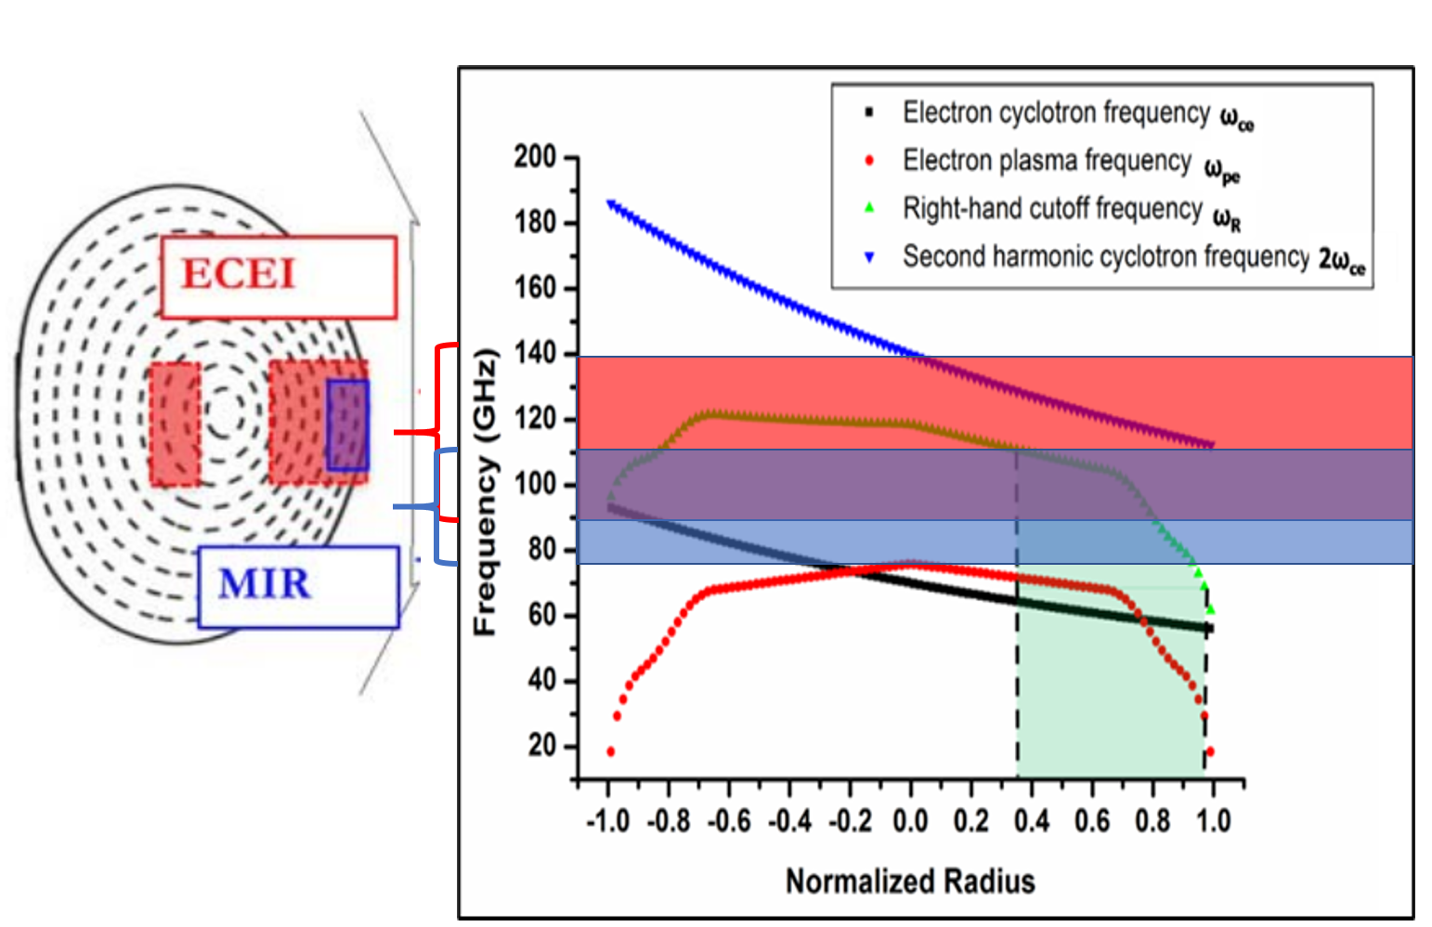

**Figure 2.** the operation frequency ranges of ECEI (red) and MIR (blue) in EAST tokamak.

1. Overview of MIR diagnostic system
   1. MIR transmitter upgrade

The transmitter source functions as the "camera flash," emitting multi-frequency signals onto the plasma cutoff layers. The received power maintains an approximately linear relationship with the transmitted power. W-band transmitter frequencies are generated using low-frequency synthesizer sources (0.65–20 GHz) and the 6x active multipliers. The diagram of transmitter source is shown in Fig. xx. An 8-input, 1-output W-band waveguide signal combiner is utilized to transmit eight independent frequency signals through a single port.

The initial transmitter source, installed in 2019, delivered a maximum output power of approximately 3 dBm (~2 mW) per frequency. However, performance degradation was observed over time due to aging coaxial cables, inadequate grounding, and insufficient cooling caused by poor system arrangement.

The transmitter source upgrade has been completed and implemented on the EAST MIR diagnostic. As shown in Fig. 3, a [**power/low-noise amplifier]** has been installed between the 8-way power combiner and the transmitter horn. This amplifier provides a maximum gain of 18 dB across all eight transmitter frequencies, with a P1dB of **xx dBm** and a noise figure of **xx dB**. The amplifier’s frequency coverage ranges from **xx to yy GHz**, meeting the requirements for MIR measurements. Additionally, the transmitter enclosure has been redesigned to include improved cooling, optimized wire connections, and enhanced accessibility for maintenance.

**Figure 3.** The upgraded illumination source.

* 1. The receiving system electronics

Figure 4 shows the schematic of EAST MIR back-end electronics module [ref]. Twelve W-band receiver antennas are placed in vertical arrays for receiving 8-tone reflected beams from 12 heights in the plasma side, through front-end receiving optics. The receiving signal is down-converted mixing with local oscillator (LO) signal which coupling by separate LO optics. The heterodyne mixing output bandwidth covers 2-18 GHz. The back-end electronics modules, following the heterodyne mixers, are used to extract the phases from 8 different frequencies.

Each individual back-end electronics unit, corresponding to a single poloidal antenna, receives an 8-tone down-converted signal. This signal is a mix of the plasma-reflected beam and the local oscillator signal. The 1 to 8 power divider, as shown in Fig. 4, is used to deliver 8 identical samples to each sub-intermediate frequency arm. The reference signal from external synthesizer drives the second-stage mixer mixing with 8-tone sample. The narrow bandpass filter 140 ± 50 MHz is placed after the second-stage mixer, which only filter out one selected frequency in need, which determined by external synthesizer source frequency. Eight individual synthesizers are used for 8-tone signal filter and selections. Their output 140 ± 50 MHz signals delivers to following I/Q mixers for phase detection.

Each individual back-end electronics module, corresponding to a single poloidal receiving antenna, receives an 8-tone down-converted signal, which is mixed by the plasma-reflected beam and the local oscillator signal. As shown in Fig. 4, a 1-to-8 power divider distributes eight identical samples to each sub-intermediate frequency arm. The reference signal from an external synthesizer drives the second-stage mixer, where it mixes with the 8-tone sample. A narrow bandpass filter with a 140 ± 50 MHz range is placed after the second-stage mixer to isolate a single frequency, as determined by the external synthesizer’s frequency. Eight individual synthesizers are used to filter and select the 8 different frequency signals. The resulting 140 ± 50 MHz signals are then sent to the following I/Q mixers for phase detection.

An external 10 MHz clock signal is used to synchronize the clocks of all synthesizers within the entire MIR system, including the 8 synthesizers in the transmitter, 8 in the receiver, 1 in the local oscillator, and all I/Q mixer drivers.

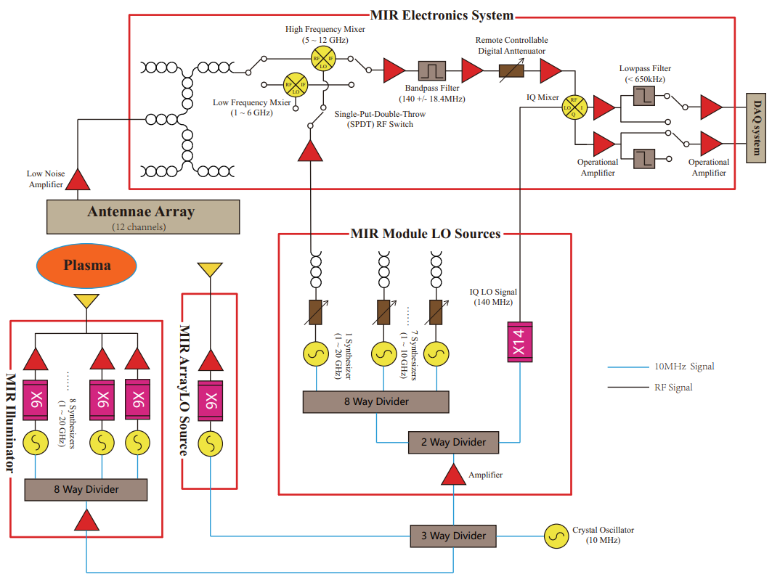

**Figure 4.** EAST MIR System Hardware Architecture.

During laboratory bench-mark testing, crosstalk between different sub-intermediate frequency arms was clearly observed. This crosstalk couples through the microstrip transmission lines on the printed circuit boards, causing non-negligible interference in phase detection. Removing the crosstalk is challenging with the current design, as the circuit boards are in close proximity within a limited space. However, optimizing the frequency separation between synthesizers helps mitigate the crosstalk issue, significantly improving the phase signal purity on each channel.[Please provide the standard synthesizer frequency gaps]

* 1. The MIR optics system

The diagram of the EAST MIR optics system is shown in Fig. 5, which includes both the transmitter and receiver optics. Optimal optics alignment and coupling are essential for reliable density fluctuation measurements. It requires (1) transmitter beam wavefront, (2) receiver array image plane, and (3) cutoff layer in the plasma matches with each other.

The MIR measurement radial coverage is **xx mm** at a major radius of **R = xxxx mm** and **xx mm** at **R = xxx mm, based on the standard EAST plasma equilibriums (shot number)**. The transmitter wavefront curvature radius is dynamically adjustable from **640 mm to 1560 mm** to accommodate different EAST plasma scenarios. On the receiver side, five high-density polyethylene (HDPE) lenses and two flat mirrors are used to receiver the reflected waves from the plasma, and direct them to the 12-channel antenna array [14]. The image plane curvature radius ranges from **570 mm to 850 mm**, depending on the plasma scenario. The spatial spacing between neighboring radial channels is adjustable from **18.8 mm to 30.8 mm**, allowing for the study of different-scale radial transport physics.

**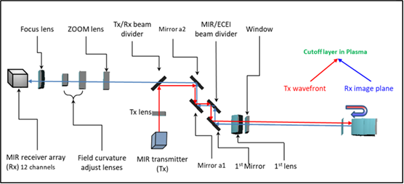****Figure 5.** Schematic diagram of MIR receiving optics and illumination optics.

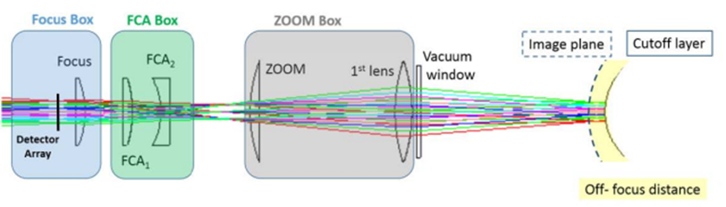

**Figure 6.** Schematic Diagram of the Composition of the Reception Optical Path Lenses.

1. The chopper experiment
   1. The quality of the MIR raw data

We referred to the operational data of the MIR system from the DIII-D tokamak. Taking DIII-D shot 157102 as an example, signal amplitude varies between 20 mV and 100 mV during the discharge while signal amplitude drops to around 9 mV to 20 mV without discharge, shown in Figure 7(a). The amplitude ratio before and after the discharge is approximately 10:1. Figure 8(b) shows the raw signals collected by EAST MIR system when the optical path was not well-aligned. It was observed that there was almost no change in the envelope before and after the discharge, which suggests that EAST MIR did not the match condition and most of the reflected signals did not collected by the receiving optics in this case. It is found that the evolution of raw data provide direct clues to calibrate the optics and optimize the MIR performace. It is also noticed that the background noise level of EAST MIR in this case is relatively high. Besides the noise from electronic system, the signals reflected back from any unintended surfaces in the optical path also contribute to the background noise, which we call as “space echo”. Unlike the desired MIR signal, the phase delays of space echos are fixed, they will not change during the discharge,

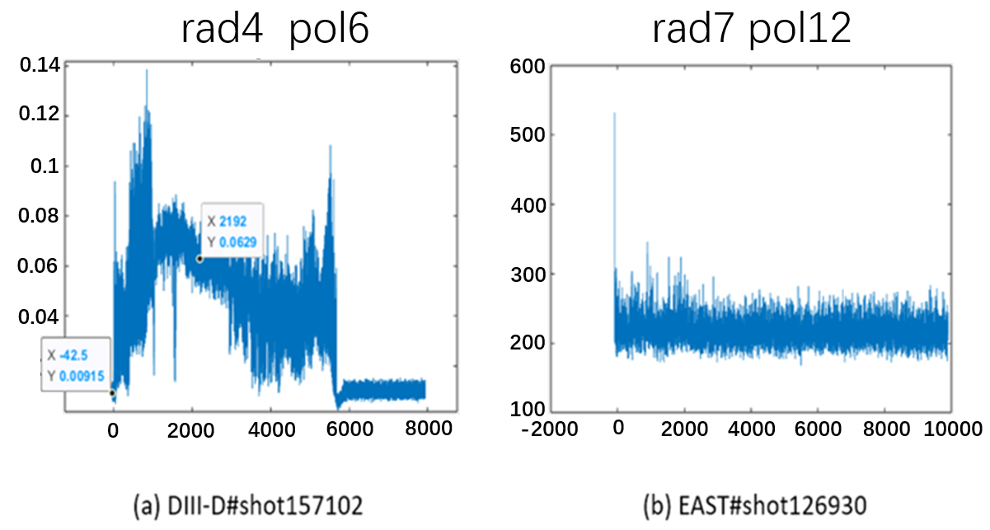

**Figure 7.** Comparison of raw data between DIII-D and EAST.

* 1. The diagram of the chopper experiment.

In order to find out how the space echo will distort the MIR raw data, we set up a chopper experiment in lab. The chopper experiment is shown in Figure 8 and 9. The chopper plate made of high-density polyethylene (HDPE) is placed at the exit of the illumination source's emission horn. By rotating the chopper plate, periodic variations of the optical length are introduced, simulating the phase changes caused by density disturbances in the cutoff layer.

To introduce an additional fix phase difference at the receiving antenna and simulate the interference from space echo signals, a W-band waveguide power divider is added at the emission end of the illumination source. The electromagnetic wave emitted from the upper waveguide horn pass through the chopper plate before entering the antenna, while the other electromagnetic wave from the lower waveguide horn is directly received by the antenna without modulation. By changing the height of the moveable platform, we can change the relative positions of the two horns to the antenna, thus the amplitude ratio of the desired MIR signal to the space echo can be varied. This allows us to verify and evaluate the effect of space echos on the extraction of the disturbance phase under different amplitude ratios.

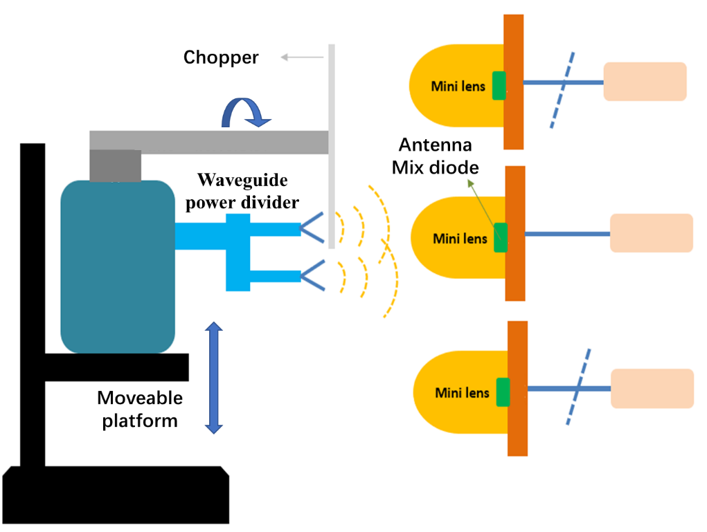

**Figure 8.** Schematic diagram of the chopper experiment setup.

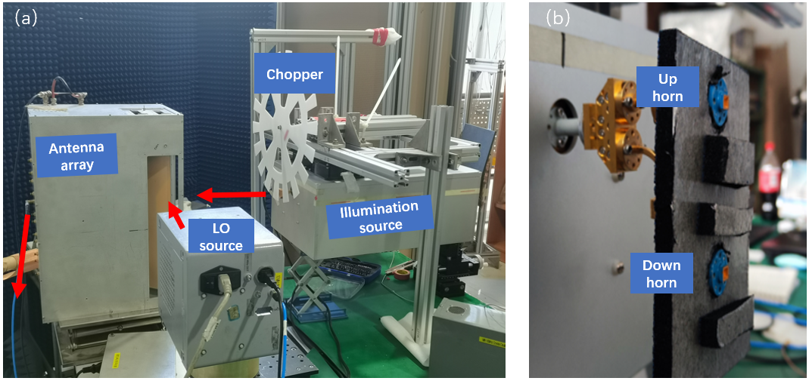

**Figure 9.** (a) table layout of the chopper experiment setup; (b) the waveguide power divider used to introduce space echo effect.

* 1. Results of the chopper experiment.

First, we adjust the mobile support platform so that the geometric center of the upper waveguide port aligns with the geometric center of the Mini Lens of the antenna while shielding the lower waveguide port. This setup corresponds to an ideal scenario without spatial echoes. In this configuration, the 79.5 GHz electromagnetic wave output from the illumination source is incident on the second antenna after passing through the chopper. The antenna's local oscillator (LO) source outputs 80.19 GHz, and the mixed signal at the second antenna, at 1.29 GHz, enters the backend electronics system. The module's local oscillator provides a 1430.12 MHz LO signal. At this time, the acquisition card only collects the 120 kHz carrier signal that has passed through the chopper at the upper waveguide port. After performing FFT processing and taking the logarithm, the frequency amplitude of the 120 kHz carrier signal is 75.84 dB.

With the above setup maintained, the upper waveguide port is shielded, and the signal from the lower waveguide port is collected, resulting in a frequency amplitude of 71.30 dB for the 120 kHz carrier signal. The purpose of sequentially shielding the upper and lower waveguide ports is to obtain the amplitude ratio of the target signal to the spatial echo. The amplitude difference between the target signal and the spatial echo signal is 4.54 dB, indicating that the intensity of the target signal is approximately 2.84 times that of the spatial echo signal.

Remove the shielding from the upper and lower waveguide ports, both signals are received simultaneously by the antenna. The time sequence diagram of the disturbance phase extracted using the HHT method is shown in Figure 10(a). When the intensity of the target signal is approximately 2.84 times that of the space echo signal, the disturbance phase can be successfully extracted.

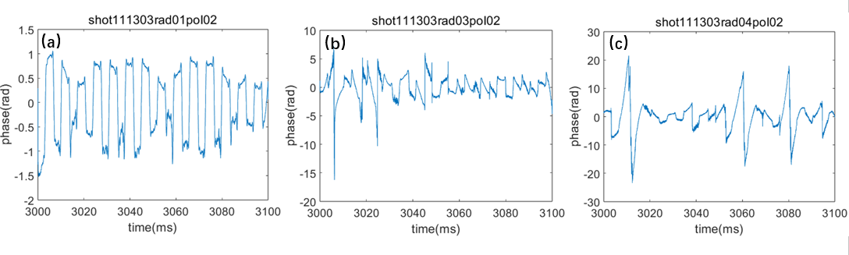

**Figure 10.** (a) The time sequence diagram of the disturbance phase when the signal-to-noise ratio is 2.84 with the introduction of spatial echoes; (b) & (c) The signal-to-noise ratios are 1.97 and 1.46 respectively.

While maintain the current frequency settings and adjust the support platform by moving the platform up by 3 cm, the amplitude difference between the target signal and the space echo signal is 2.94 dB, corresponding to a signal-to-noise ratio 1.97. The extracted time sequence diagram of the disturbance phase is shown in Figure 10 (b), indicating relatively poor periodicity in the sequence. Continuing to raise the platform by 3 cm, the intensity of the target signal is approximately 1.46 times that of the spatial echo, and the extracted time sequence of the disturbance phase is shown in Figure 10 (c). It is clearly shown that the periodic phase modulation is difficult to restore.

The chopper experiment results show that when the ratio of the effective signal amplitude reflected from the plasma to the amplitude of the space echo is less than 1.97, the HHT-based data processing method can no longer correctly extract phase disturbances. The chopper experiment confirms from an experimental perspective that it is essential to maximize the intensity of the effective signal reflected from the cutoff layer while minimizing space echos, in order to obtain high-quality MIR diagnostic data and successfully extract phase disturbances.

1. Preliminary experimental results of the MIR system on EAST.

In the first stage of MIR commissioning and operation on EAST, the system has realized the basic one-dimensional (in poloidal direction) diagnostic capability. The MIR system's illumination source emits detection wave with single frequency at 70 GHz, while the antenna's local oscillator (LO) source outputs a 74 GHz LO signal. The module's local oscillator source provides a secondary mixing LO of 4140.05 MHz. In EAST shot 141699, coherent modes with frequencies between 60 kHz ~ 70 kHz are observed in channels 3-5 of the MIR antenna array, as shown in figure 11.

**Figure 11.** Phase spectrum diagram of polodial channel 3、4、5 in EAST SHOT #141699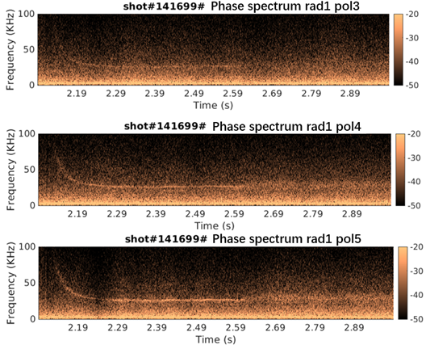.

In EAST shot 141745, the phase and amplitude spectra of the fifth antenna are shown in Figure 12. A correlation analysis was performed between the fourth and fifth antennas over a 50 ms time window from 2.3s to 2.35s during the discharge, shown in Figure 13. The analysis results indicate the presence of coherent modes with frequency range between 60 kHz and 70 kHz.

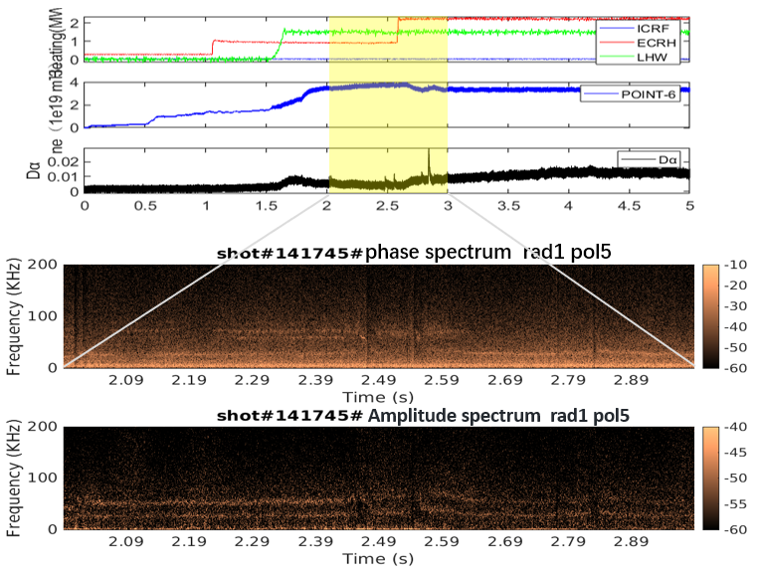

**Figure 12.** Phase and amplitude spectrum diagram of polodial channel 5 in EAST SHOT #141745.

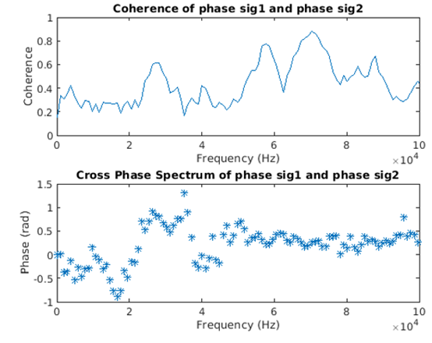

**Figure 13.** Correlation analysis between the channel 4 and 5 about EAST SHOT #141745.

1. Summary

The details of EAST MIR implementation are provided. To address the space echos encountered during the practical operation, we designed an chopper experiment in lab to find out the minimum signal-to-noise ratio required for correctly extracting the disturbance phase. Furthermore, coherent modes have been observed in the EAST boundary plasma via MIR system. The MIR tuning up is still in investigation to achieve the expected 2-D density fluctuation evolution.

Acknowledgments

This work is supported by National Magnetic Confinement Fusion Energy Program of China under Contract No. 2019YFE03020001. The authors wish to thank the EAST group for the valuable help on the engineering design.

References

[1] E. Mazzucato, *Microwave imaging reflectometry for the visualization of turbulence in tokamaks*, Nucl. Fusion 41 (2001) 2.

[2] E. Mazzucato, *Microwave reflectometry for magnetically confined plasmas*, Rev. Sci. Instrum. 69 (1998) 6.

[3] E. Mazzucato, *Numerical study of microwave reflectometry in plasmas with two-dimensional turbulent fluctuations*, Review of scientific instruments 69 (1998).

[4] R. Nazikian, C. J. Kramer, and E. Valeo, *A tutorial on the basic principles of microwave reflectometry applied to fluctuation measurements in fusion plasmas*, Phys. Plasmas, 8 (2001) 5.

[5] T. Munsat, et al., *Microwave imaging reflectometer for TEXTOR,* Review of scientific instruments 74 (2003).

[6] C. M. Muscatello, et al., *Millimeter-wave imaging reflectometry on the DIII-D Tokamak,* Nuclear Fusion (2014).

[7] R. Sabot, et al., *Development of Microwave Imaging Diagnostics for WEST Tokamak,* Journal of Fusion Energy 38 (2019).

[8] W. Lee, et al., *Microwave imaging reflectometry for KSTAR,* Journal of Instrumentation 7 (2012).

[9] S. Yamaguchi, et al., *Microwave imaging reflectometry in LHD*, Review of scientific instruments 77 (2006).

[10] Z. Shi, et al., *Development of microwave imaging reflectometry on the HL-2A tokamak*, Review of Scientific Instruments 85 (2014).

[11] Y. Zhu, et al., *Millimeter-wave imaging diagnostics systems on the EAST tokamak*, Review of Scientific Instruments 87 (2016).

[12] W. Liao, et al, *Bench test of microwave imaging reflectometry system for EAST tokamak*, Journal of Instrumentation 15 (2020).

[13] T. Munsat et al., *Laboratory characterization of an imaging reflectometer system*, Plasma Phys. Controlled Fusion 45 (2003) 4.

[14] Zhu Y, Zhao Z, Tong L, et al., *Optics system design of microwave imaging reflectometry for the EAST tokamak*, Plasma Science and Technology 18 (2016) 4.